PFAS Talking Points

General
- Per- and Polyfluoroalkyl substances (PFAS) are a large group of manufactured organic chemicals that are used in a variety of products for their nonstick properties (e.g., Teflon, Scotchgard), as well as in industrial applications such as firefighting. Aqueous Film Forming Foam (AFFF) usage at military bases and airports are sources of PFAS in drinking water supplies near those locations.

- This is one of the most rapidly changing landscapes in drinking water contamination. [Company Name] is investing time and resources and has engaged with experts in the field to understand PFAS occurrence, fate, and transport in the environment.

- PFOA has been phased out of production, but replacement compounds, such as “GenX,” have been developed and are increasingly being detected in the environment. There are thousands of known PFAS compounds.

- Even though recent efforts to remove PFAS have reduced the likelihood of exposure, some products may still contain them. If you have questions or concerns about products you use in your home, contact the Consumer Product Safety Commission at [insert contact number].

- PFAS have been linked to various toxicological issues and are highly persistent in the environment. The U.S. Environmental Protection Agency (EPA) has set a non-enforceable Health Advisory Level of 70 nanograms per liter or parts per trillion (ppt) for combined PFOA and PFOS.

- Several States have established requirements for different PFAS ranging from MCLs to notification and response levels to guidance levels. The EPA released a PFAS Action Plan in February 2019 and made a preliminary decision to establish drinking water standards for PFOA and PFOS in March 2020.

- Most contaminants are measured using concentration units such as ppm, ppb, and ppt. To realize how small a value this is and how difficult this contaminate is to trace in the environment, see the analogies listed below:

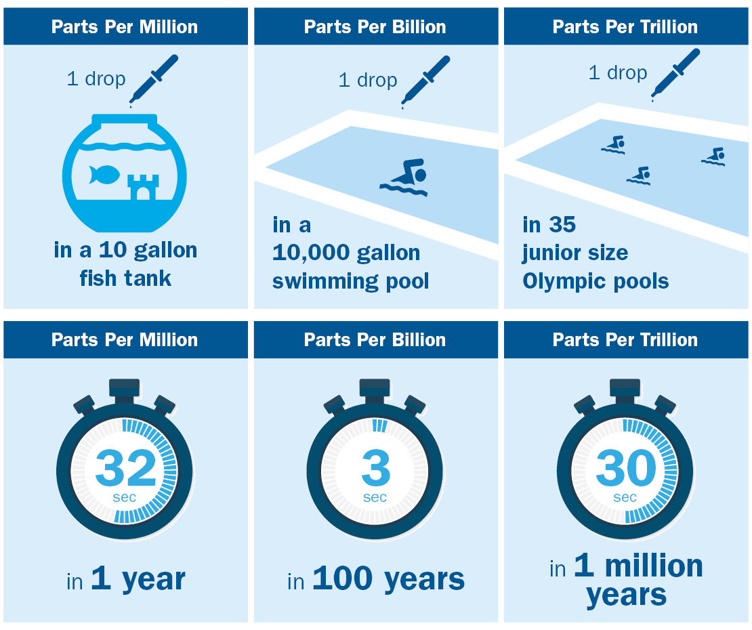

UCMR5 Background, Monitoring, use of Data
- The Unregulated Contaminant Monitoring Rule (UCMR) is a program to monitor for priority unregulated contaminants in drinking water every five years.

- U.S. EPA uses the UCMR to collect data for contaminants that are suspected to be present in drinking water and do not have health-based standards set under the Safe Drinking Water Act (SDWA).

- In prior rounds, monitoring occurred at all large systems serving greater than 10,000 people and representative number of smaller systems.
  - For this round monitoring will occur at all systems between 3,300 and 10,000 people if funding is available and then a representative number of systems with populations below 3,300
  - EPA will pay for the analysis of all samples from systems serving 10,000 or fewer people.

- Occurrence data are collected through UCMR to support the EPA Administrator's determination of whether to regulate contaminants in the interest of protecting public health.
- Occurrence data collected under UCMR5 will help water systems be prepared when the health effects data are available. There is no need to take specific action, even if PFAS were detected, unless otherwise directed by your water system or health official. If a concern remains, contact your healthcare provider.
- This is 5th UCMR and runs from 2022-2026.
  - 29 PFAS analytes and lithium
    - PFOA and PFOS were included on UCMR3
      - Analytical methods have improved so may detect PFOA or PFOS in UCMR5 even though not detected in UCMR3
      - EPA has decided to develop drinking water standards for PFOA and PFOS
      - Current Health Advisory for PFOA and PFOS (70 ppt combined) and must also be aware of state limits, advisory levels, and guidance
  - Monitoring will occur between 2023-2025
  - Next steps
    - Occurrence is one leg of the stool for regulation – occurrence, treatment, and health effects; do not necessarily have all the information on all of these for the 29 PFAS analytes that included in UCMR5
    - Having occurrence information puts us in position to be prepared in the event EPA or the state develop regulations
- More Information on the UCMR Rule: https://www.epa.gov/dwucmr/learn-about-unregulated-contaminant-monitoring-rule

PFAS Mitigation
- [Company Name] has and continues to conduct extensive screening/monitoring to identify potential impacted sites and then implement solutions in those systems that exceed the health advisory levels.

- [Company Name] consistently meets or surpasses all U.S. EPA and [State DEP] regulations. As new federal water quality regulations are set by U.S. EPA, we will make necessary improvements or treatment adjustments to comply with those standards.

- When U.S. EPA and/or the [State DEP] lower the health advisory limit for combined PFAS, [Company Name] will meet the new requirement.

- We are also actively assessing treatment technologies that can effectively remove PFAS from drinking water, because we believe that investment in research is critical for addressing this issue.

Boiling, Filters, Bottled Water
- There would not be any expected benefit to boiling water to remove PFAS, because it is a chemical compound.

- Some customers may make the personal choice to use water filters or drink bottled water. Certified water filtration systems can reduce levels of PFAS below the Environmental Protection Agency’s health advisory levels; however, the water provided by [Company Name] meets or exceed those levels.

- If your tap water or private well tap water has high PFAS levels, choose an alternative water source. You should choose bottled water brands that are confirmed to have low PFAS concentrations and packaging without PFAS. See question below.

- Reduce your risk of exposure to these chemicals by using bottled water or other licensed drinking water that has been tested for these chemicals or that uses a treatment that removes these chemicals (specifically activated carbon or reverse osmosis). Many major bottled water brands use this treatment.

PFAS Environment and Products
- Research has suggested that exposure to PFOA and PFOS from today’s consumer products is typically low. Here are some helpful ways you can assist:
  - Avoid - Non-stick cookware containing PFAS. Buy stainless steel and cast-iron pots and pans. If you have old non-stick pans you cannot part with, do not heat them over 450ºF or use them in the oven. When the coating shows signs of wear-and-tear, it is time to let them go.
  - Avoid - Stain-resistant treatments by asking for furniture, carpet and cleaning supplies that do not contain PFAS or are not marketed as “stain-resistant.”
  - Purchase - PFAS-free products from companies who have committed to eliminating PFAS from their manufacturing. A list from the CDC’s Agency for Toxic Substances and Disease Registry can be found here.
  - Be Aware - Water and stain resistant treatments for textiles used as clothing or carpets are often made using PFAS. Many companies are seeking to eliminate PFAS from their stain and water-resistant products; however, until these transitions are complete it is important to be aware that these products may contain PFAS, particularly if they are older products:
    - PTFE (e.g., Teflon® coating, Gore-Tex® materials)
    - PFOS or PFBS (e.g., Scotchgard® coating), older items contain PFOS (e.g., Polartec® materials)
- With cosmetics, be cautious when ingredients contain the words “fluoro” or “perfluoro.” PFAS are found in certain types of dental floss, nail polish, facial moisturizers, eye make-up and more. Some ingredients to look out for:
  - PTFE
  - Perfluorononyl Dimethicone
  - Perfluorodecalin
  - C9-15 Fluoroalcohol Phosphate
  - Octafluoropentyl Methacrylate
  - Perfluorohexane
  - Pentafluoropropane
  - Polyperfluoroethoxymethoxy Difluoroethyl Peg Phosphate
  - Polyperfluoroethoxymethoxy Peg-2 Phosphate
  - Methyl Perfluorobutyl Ether
  - Perfluorononylethyl Carboxydecyl Peg-10 Dimethicone
  - Perfluorodimethylcyclohexane
  - Perfluoroperhydrophenanthrene

Additional Resources:
- CDC - Agency for Toxic Substances and Disease Registry -https://www.atsdr.cdc.gov/pfas/health-effects/exposure.html
- CDC - Agency for Toxic Substances and Disease Registry - https://www.atsdr.cdc.gov/pfas/health-effects/index.html
- EPA - Per- and Polyfluoroalkyl Substances (PFAS) - https://www.epa.gov/pfas
- EPA State Information - PFOA, PFOS and Other PFAS - https://www.epa.gov/pfas/us-state-resources-about-pfas

